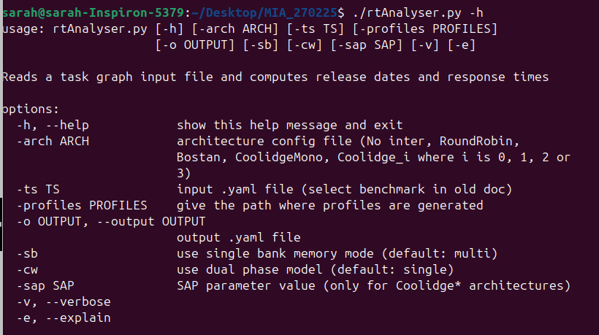
./rtAnalyser.py -profiles examples/profiles -arch Bostan -ts examples/example2_dflow.yaml -o /tmp/output_mia_15245.yaml
Schedulable with duration 190.

./rtAnalyser.py -profiles examples/profiles -arch Coolidge_3 -ts examples/Coolidge5.yaml -o /tmp/output_mia_15245.yaml
Schedulable with duration 259.
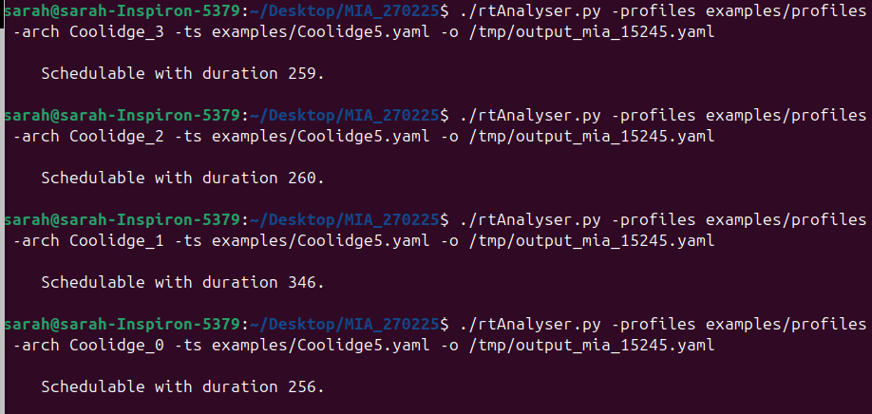
./rtAnalyser.py -profiles examples/profiles -arch Bostan -ts /home/sarah/Desktop/CNN-to-DAG/dag_output_simplified.yaml -o /tmp/output_mia_15245.yaml

